

4/21/2021



Mahmoud Ahmed Abdelghany Sec: 4 BN: 8

Mohamed Ragab Fergany Sec: 3 BN: 30

Abd Elrahman Elsayed Abdo Sec: 2 BN:30

Mario Magdy Wageh Sec: 3 BN: 16

Ahmed Elsayed Ragab Sec: 1 BN: 4

PowerLink Team

Robotic Arm

Supervised by: Dr. Abdelatif

**i. Abstraction**

In this paper, we will cover the basic steps for implementing the robotic arm project, starting from design, through testing, and finally production.

**ii. Introduction**

This project is one of the most important automatic control projects, especially in the field of industry, as the automatic arm is located in most factories, which facilitates the control process and increases productivity.

**iii. Design Process**

In this project there are 3 degrees of freedom, so if we want to move to a point in the vacuum then we must use 3 motors to achieve this point in addition to a fourth motor to control the gripper.

So, we have to go through the mechanical design first, then the electrical design, and then combine them together.

**iV. Mechanical Design**

Choosing the dimensions and the number of joints in the arm, which is one of the very important things, so the design must be studied well, taking into account the strong momentum affecting the arm in the sleep mode and also the force affecting it in the motion position, so we used a ready-made 3D design.

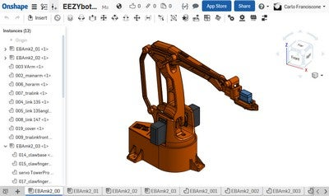

Figure 1: 3d design of robotic arm

This design consists of three main parts:

* The main base
* The main arms
* The gripper

**Assembling the main base**

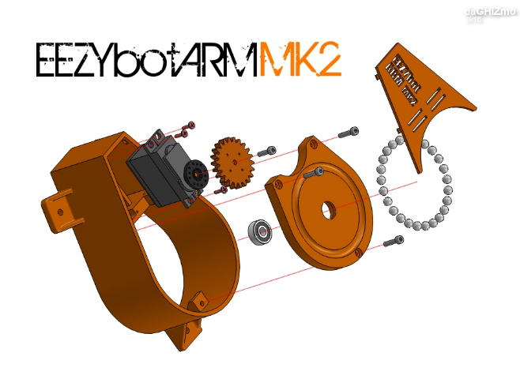

Figure 2: Assembling the main base

**Assembling the main arms**

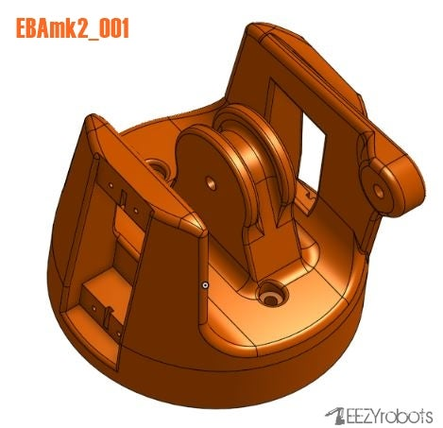

Figure 3: the base part that holding the arm

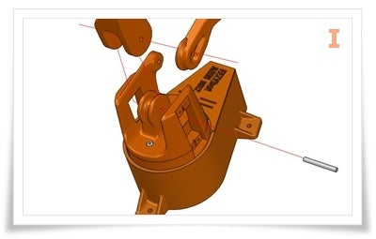

Figure 4: connecting the base and the arms

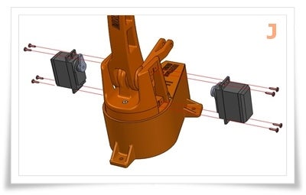

Figure 5: installation of two arm motors

**Assembling the gripper**

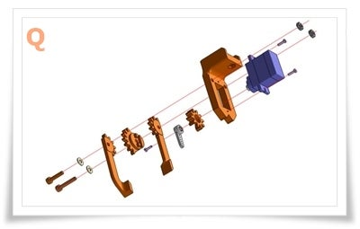

Figure 6: Assembling the gripper

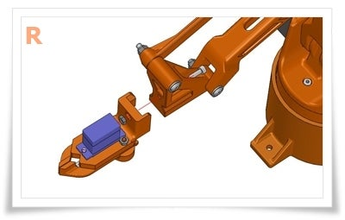

Figure 7:The Gripper

**V. Electrical design**

**Electrical system description**

Here comes the electrical design part, which is the soul of the robotic arm. All parts must be carefully selected.

Components:

* 3 Servo motor High Torque 180 degrees (90in each direction) 500mA-900mA.

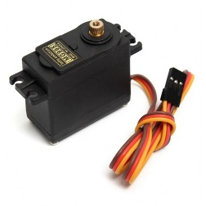

Figure 8: servo motor high torque

* 1 servo motor low torque 180 degrees (90in each direction).

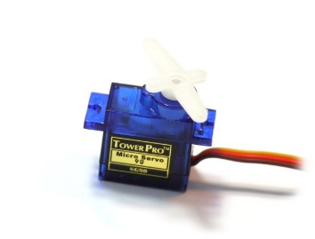

Figure 9: servo motor low torque

* Arduino nano

This is the main controller it will take the orders from GUI through MODBUS RTU and it will send the electrical signal to the servo motor driver through .

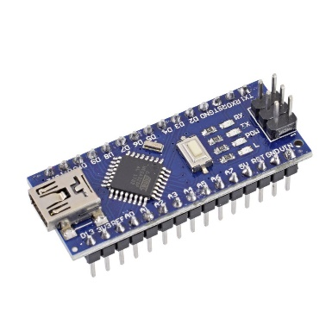

Figure 10: Arduino nano

* Step down converter(3A)

It will convert the voltage level from 12 volts to 5 volts (the rated voltage of motors).

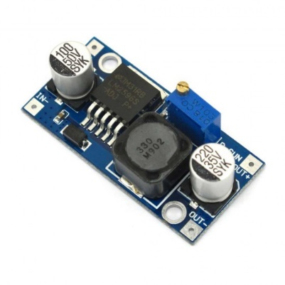

Figure 11: step down converter

* PCA9586

16 channel 12-bit PWM servo motor driver module which will take the order from Arduino and generate the PWM signal for the 4 motors, Powered by 5 volts from DC-Dc converter.

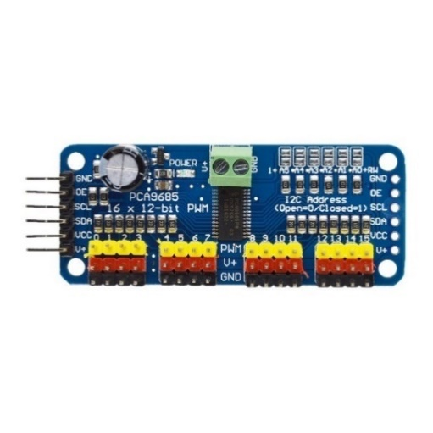

Figure 12: 16 channel servo motor driver

**Electrical connection**

we have two main parts:

* Servo Motor Driver + DC-DC converter (Part1)
* Arduino nano (Part2)

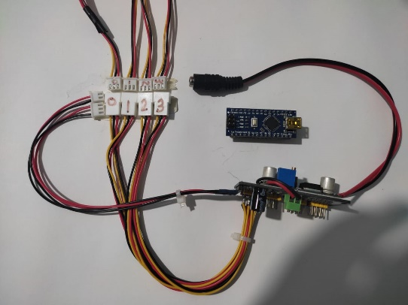

Part1

Part2

Figure 13: Electrical Wiring

* Part1:

In this part there is four 3 pin connectors for the motors and they numbered from 0 to 3, and we have two connectors for Arduino one for the power (A) and the other for communication (B), and the last one is a 12 volts DC power jack.

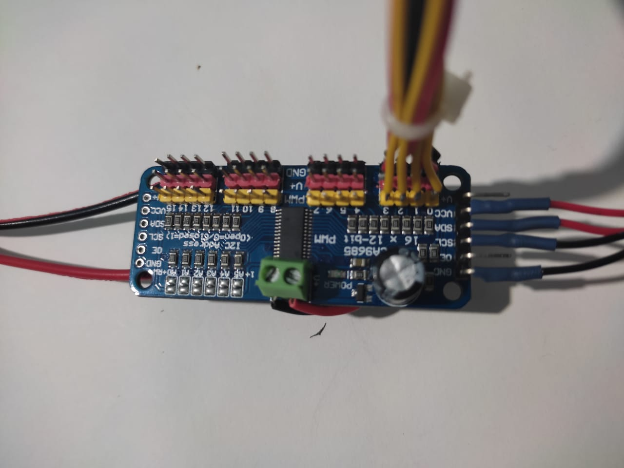

Figure 14: Part1

* Part2

In this part there is two connectors from part1 one for power and the other for the communication and we have one (USB-micro USB) to connect the Arduino to the laptop.

power

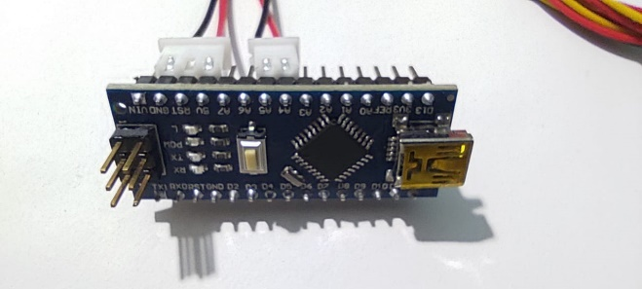

Figure 15: Part2



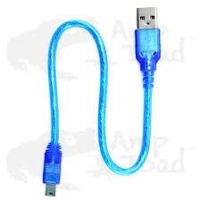

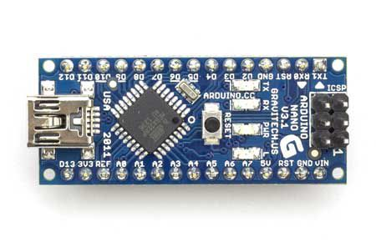 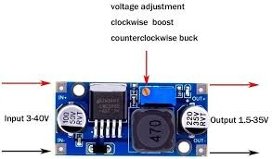 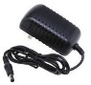



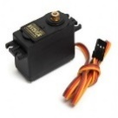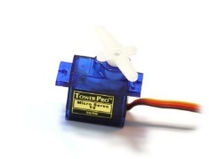

**Vi. Control method**

The objective is to achieve a point in a 3d space

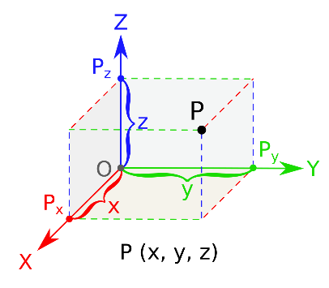

Figure 16: 3D Space

so, we want to control the position of the three main motors:

* Base Motor (90 degrees corresponding to motion in XY plan)
* Right Arm Motor (63 degrees corresponding to motion in ZX plan)
* Left Arm Motor (81 degrees corresponding to motion in YZ direction)

Due to mechanical constrains of the Robotic Arm design the right & left motors are calibrated to their optimum angle values which are 63 degrees and 81 degrees respectively.

**PWM Vs Degrees Mapping**

These motors are running at PWM signal with duty cycle (2%-12.5%) at frequency 50 Hz so, if we want to achieve a mechanical degree, we can use this relation:

Figure 17: relation between duty cycle and degree

the previous relation is deduced by calibration and tunning.

**Vii. Algorithm**

We use Arduino nano as our microcontroller to receive the values of the required PWM signals as an input which corresponding to a specific angle from GUI and process our algorithm then send a signal to the servo motor driver as output which the last will supply the required motor with power and control signal.

**Programming code**

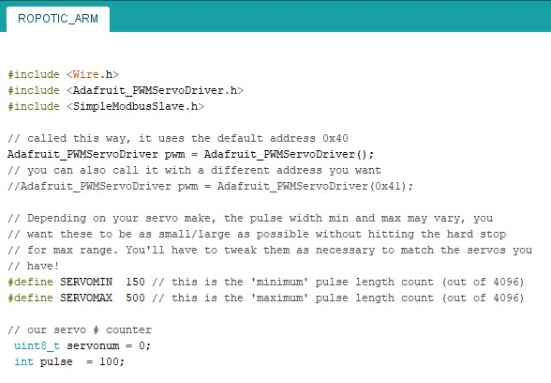

Figure 18: importing libraries & variable declaration

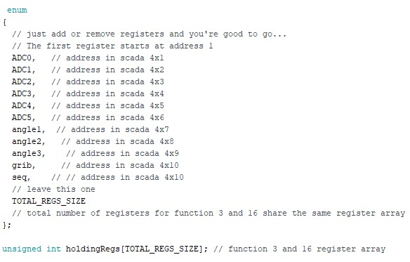

Figure 19: Holding Registers

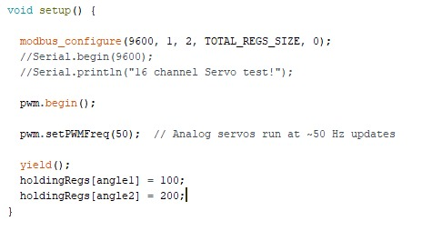

Figure 20: communication protocol initialization

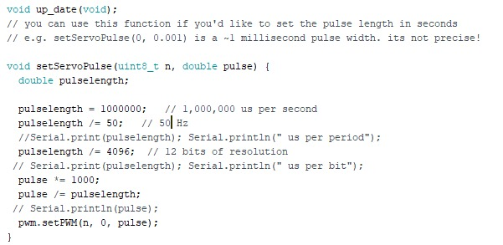

Figure 21: Holding Registers Update

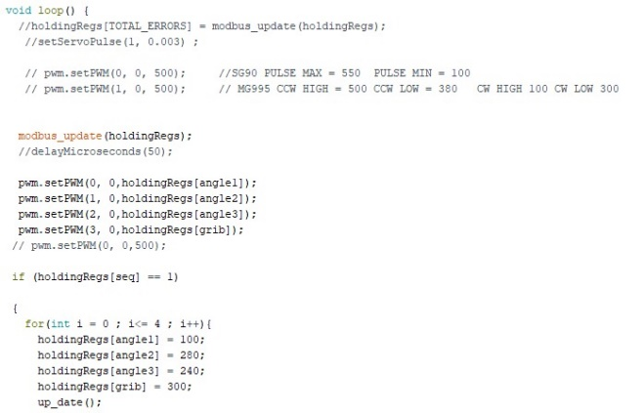

Figure 22: Main code

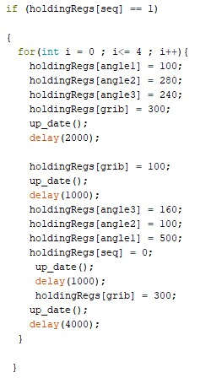

Figure 23: Recorded sequence (motion)

**Viii. Graphical User Interface (GUI)**

This GUI is designed with InduSoft web studio, all motion control signals come from the GUI (Desktop Application) through MODBUS RTU communication protocol.

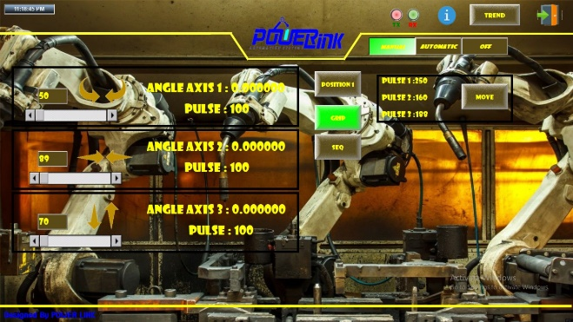

Figure 24: GUI

In this program we have a communication sheet which includes the addresses of the required registers to be accessed on the microcontroller also we specify the required communication process (Writing & Reading).

**GUI symbols**

* Three slide bars each one

control an axis of the robot.

* Textbox + Arrows to control the robot axes step by step.
* Grip button to open and close the robot gripper.
* SEQ button to perform the pre-programed sequence of motion which written in the Arduino program.

**Robotic Arm Operating Modes**

There are 4 modes of operation

1. Continuous mode using slide bar
2. Step mode using textbox + Arrow
3. Move mode
4. Pre-programmed sequence

**iX. Resources**

Mechanical design source:

[Web Link](https://www.instructables.com/EEZYbotARM-Mk2-3D-Printed-Robot/)

Source Code:

[Web Link](https://drive.google.com/file/d/1-CldjZxQ7N5xvcniNCLGuqy-hDwyKgqp/view)

Bill of material:

[Web Link](https://docs.google.com/spreadsheets/d/1CQTHSm7B-th6YA7SwUdaTo6pFQ4QRODkvnbeviX2_JM/edit#gid=374804845)

**X. Conclusion**

Finally, in this project we increase our technical and laboratory skills after implementing this project which is considered one of the most important project in industry field and we know how to integrate between the mechanical system and the electrical system and deal with programming code, in addition to gain more communication skills and team work and we looking forward to add some new features to this project and apply more related control projects.